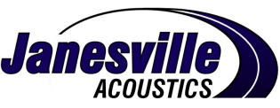

A UNIT OF JASON INDUSTRIES, INC.

Supplier Quality Requirements Manual

11/24/2014
Table of Contents
SECTION 1.0 – INTRODUCTION 5
Confidentiality 5
Regulatory Conformity 5
References 6
SECTION 1.1 – SUPPLIER MANAGEMENT RESPONSIBILITY 7
Customer Focus 7
Quality Management System 7
Management Representative 7
Management Review 7
Communication 7
SECTION 1.2 – SUPPLIER QUALITY MANAGEMENT SYSTEM 9
Managing Systems and Processes 9
Quality System General Requirements 9
Quality System Documentation Requirements 9
Supply Chain Quality Management 9
SECTION 1.3 – PURCHASING 10
Supplier Selection 10
Supplier Survey 10
Supplier Assessment 10
Terms and Conditions of Purchase 10
Supplier Review 10
SECTION 1.4 – PRODUCT QUALITY CRITERIA 11
Acceptance Criterion 11
Receiving Inspection 11
Traceability 11
Supplier Liability 11
Federal and International Banned and Restricted Substances and Processes 12
Non-Conforming Material in Route 12
Non-Conforming Material at Janesville 12
Containment Requirements 13
On Site Rework and Sorting 13
Third Party Rework, Sorting and Containment 13
SECTION 1.5 – PACKAGING AND LABELING 14
Packaging 14
Returnable Containers 14
Interior Dunnage 14
Expendable Packaging Materials 14
Pallets 15
Part Quantities and Combinations 15
Labeling 15
SECTION 1.6 – PRODUCT REALIZATION PROCESS 18
Advanced Product Quality PLANNING (APQP) 18
Production Part Approval Process (PPAP) 18
Notification of Requirements 18
PPAP Elements 18
PPAP Sign-Off Checklist 18
Part Submission Warrant (PSW) 18
Material/Performance Test Results 18
Qualified Laboratory Documentation 19
Dimensional Results (ISIR) 19
Appearance Approval Report (AAR) 19
Process Failure Mode and Effects Analysis 19
Process Flow Diagrams 19
Suppliers’ Supply Chain Diagram 20
Control Plans 20
Key Characteristics 20
Gage Repeatability & Reproducibility (R&R) 20
Packaging Proposal 21
Supplier Product Launch Containment Process (Safe Launch) 21
IMDS …………………………………………………………………………………………………………………………21
Inspection and Test Records 21
Annual Revalidation 21
SECTION 1.7 – CHANGE/DEVIATION REQUIREMENTS 23
Customer Notification 22
Temporary Deviation 22
Examples requiring an Engineering Change / Deviation Request 22
Process Change Notifications - PCN 23
Pre-Production Level PPAP Deviation 23
Equivalent or Alternate Materials 24
SECTION 1.8 – SUPPLIER SCORE CARDS 24
OVERALL SCORING 25

Supplier Performance Matrices
Parts Per Million (PPM) Performance…………………………………………………………………………………26
On Time Delivery Performance……………………………………………………………………………..………….27
Cost Reduction / Innovation……………………………………………………………………………………………28
Supplier Response Time to Non-conforming Product……………………………………………………………….29

Problem Resolution………………………………………………………………………………………………………….30
Supplier Response…………………………………………………………………………………………………………..30
Supplier Quality Improvement Plan (QIP)………………………………………………………………………………….30

APPENDIX……………………………………………………………………………………………………..…….…………31

Forms
Examples

SECTION 1.0 – INTRODUCTION
The Purpose of this manual is to define for our current and potential new suppliers Janesville Acoustic’s expectations and requirements that will sustain a long-term mutually beneficial relationship.

- Suppliers to Janesville Acoustics are expected to implement and maintain a robust Quality Management System which promotes defect free products through prevention, monitoring and continual improvement.

- All expectations and requirements are intended to assure safe, reliable products from Suppliers, which meet our customers’ requirements for quality, delivery, and price.

- We are committed to working with our Suppliers to assist in meeting this intent and to provide for continual improvement, emphasizing defect prevention and waste reduction in the supply chain.

- Janesville Acoustics will assess each Suppliers ability to comply with the requirements contained in this manual and based on the perceived risk assessment may include an on-site audit of the facility by Janesville Acoustics Supplier Quality or plant personnel.

Janesville Acoustics expects all suppliers to acknowledge and comply with the requirements contained in this manual. Suppliers are encouraged to reply back to the Sign off Documentation located at the end of the Supplier Quality Manual and submit it via e-mail to appropriate Commodity Manager.

Suppliers are also encouraged to visit Janesville Acoustic’s homepage at www.Janesville.com for up to date information including our Supplier Quality Requirements Manual , How to Contact US including Janesville Acoustics Worldwide locations and our full Purchase Order Terms and Conditions.

At Janesville Acoustics we see suppliers as a key factor in our current and future business as well as an extension of our own company. This manual should be used as a minimum guideline for Supplier Quality requirements in doing business with Janesville Acoustics.

Confidentiality
The Supplier may be provided access to confidential and proprietary information, including, without limitation drawings, specifications, documents, or any information provided by Janesville Acoustics in any form or means. This includes production services of potential, current and former suppliers, providing any services for the use in any Janesville Acoustics and assembly process, whether the product is being provided directly by the supplier, or is purchased from sub-tier suppliers. Disclosure in any form, without written authorization is prohibited; all Janesville Acoustics provided documentation to be maintained in a secure environment.

Regulatory Conformity
The supplier must own the patent or copyright and be properly licensed that allows it to lawfully manufacture the product, or utilize the manufacturing process. The duration of the requisite Intellectual Property must be sufficient to cover the term of the proposed supply agreement. The supplier must identify any third party Intellectual Property Rights that could interfere with the proposed supply agreement.

Products provided and shipped shall be in compliance with all applicable laws and regulations of the following:

RoHS – Restriction of Hazardous Substances Directive - adopted by the European Union in Feb 2003 and
recast in July 2011. For more information on the regulations governing RoHS compliance:
http://www.bis.gov.uk/nmo/enforcement/rohs-home

REACH – Registration, Evaluation, Authorization, and restriction of Chemicals - regulation which was
adopted by the European Community in June 2007. For more information:
http://ec.europa.eu/enterprise/sectors/chemicals/reach/index_en.htm

Conflict Minerals – Certain minerals which are mined in conditions of armed conflict and human rights
abuses, mostly in the eastern provinces of the Democratic Republic of the Congo (DRC) which is located in
Central Africa. Legislation concerning this issue was signed into law as part of the Dodd-Frank Wall Street
Reform and Consumer Protection Act in July 2010. For more information:
http://www.sec.gov/rules/proposed /2010/34-63547.pdf

Country of Origin – Suppliers are required to have the country of origin available upon request for each
item supplied to Janesville.

Free Trade Agreements – The United States has free trade agreements with over 17 countries. These
Free Trade Agreements are bilateral agreements between two governments, and in some cases like the
North American Free Trade Agreement (NAFTA), are multilateral agreements among several parties. These agreements eliminate tariffs, quotas, and preferences on most (if not all) goods traded between the
Countries listed on the agreement. For more information: http://www.ustr.gov/trade-agreements/freetrade-
agreements.

Suppliers are responsible to provide source documentation for products they supply for each of these
regulations as requested by Janesville. (More information on the Terms and Conditions of Purchase can be
found at http://www.Janesville.com).

References
This manual does not replace or modify in any way the requirements contained in any of the ISO or AIAG manuals, nor is it intended to replace a supplier’s existing quality system. Janesville recommends that all suppliers obtain and use as a guide in developing their own quality systems the latest revisions of the ISO and AIAG manuals.
- ISO 9001:2008, Quality Management Systems
- ISO/TS 16949:2013 edition
- Production Part Approval Process (AIAG) 4th Edition
- Potential Failure Mode and Effects Analysis (AIAG) 4th Edition
- Advanced Product Quality Planning and Control Plan (AIAG) 2nd Edition
- Measurement System Analysis (AIAG) Version 4
- Statistical Process Control (AIAG) Version 3

SECTION 1.1 – SUPPLIER MANAGEMENT RESPONSIBILITY

Customer Focus
Supplier management shall ensure that Janesville needs and expectations are determined, converted into requirements, and fulfilled with the objective of achieving customer satisfaction. Needs and expectations of Janesville include conformance to design and performance specifications, reliability, delivery, cost management and technical support.

Quality Management System
Supplier management shall define and endorse a written quality system. The supplier shall ensure that this quality system is understood, implemented and maintained at all levels of the organization. It shall define personnel within the organization with the freedom and authority to:
- initiate actions to prevent any nonconformities
- identify and record problems relating to the product, process and quality system
- initiate, recommend or provide solutions
- verify the implementation of solutions
- control further nonconforming product until deficiency or unsatisfactory condition has been corrected.

Management Representative
Supplier Management shall appoint a member of the suppliers own management with the defined authority to
- ensure that a quality system is established, implemented and maintained
- report the performance of the quality system to the suppliers’ management for review and at sufficient intervals to serve as a basis for improvement and to detect performance degradation.
- respond to Janesville inquiries reference containment, resolution and implementation of permanent corrective actions due to non-conformities.

Management Review
Supplier Management shall internally review the degree of compliance and effectiveness of the quality system.

Inputs to management review could include:
- audit results and schedules
- customer feedback
- process performance and product conformance
- status of preventive and corrective actions
- follow-up actions from earlier management reviews
- changes that could affect the quality management system.

Outputs to the management review should be:
- improvement of the system and its processes
- improvement of product related to customer satisfaction
- resource needs

Communication
Each Supplier is required to set up a business email address for Janesville non-confidential communications such as Score Cards, PPAP requests, Supplier Correct Action Reports, Non-Conforming Materials notification, Returned Goods Authorization requests, Policy Change Letters, or other announcements. Changes to email addresses must be communicated to the Commodity Manager prior to inoperability.
The Supplier is responsible for the internal distribution of the information sent to a common account. The Supplier shall ensure that communication takes place between its various levels and functions regarding the processes of the quality system and their effectiveness.
The supplier will provide and maintain a current contact list for their organization with Name, title, contact number (direct) and e-mail.

The Suppliers will address all communications pertaining to engineering requests, potential or in-transit quality issues, delivery issues, and any other Purchase Order related issues to the Purchasing Commodity Manager.
The Suppliers will address all communications pertaining to PPAP, SCAR resolution and design, material, engineering or process deviations to the Commodity Manager (CM), associated Janesville Facility Quality Manager (QM) and the Supplier Development Manager (SDM).

The table below further defines communication response requirements.

SUPPLIER COMMUNICATION & RESPONSE TABLE
WHAT | TO WHO | WHEN
PPAP Request | QM, CM, SDM | Acknowledge receipt within 2 business days  Complete as indicated on the PPAP request.
Request for Deviation/Change | QM, CM, SDM | 15-30 days prior to proposed effective date
SCAR (or Non-Conformance) | QM, CM, SDM | Acknowledge receipt and implement a containment plan within 24 hours (business day) of the initial defect.  Completed Form 4-31-082 within 12 business days  Continual update every 7 business days until Form 4-31-082 complete through D8
Return Goods Request | QM, CM | Within 7 days
Dispute Charge Back/Debit | CM, SDM | Within 10 working days of receipt of discrepant material unless otherwise waived.
Potential Missed Shipment | Contact Listed on the Purchase order, CM | Immediate notification is required.
Ownership or Key Management Change | QM, CM, SDM | Within 2 business days

SECTION 1.2 – SUPPLIER QUALITY MANAGEMENT SYSTEM

Managing Systems and Processes
Each supplier organization should establish quality managing systems with:
- defined systems and process that can be clearly understood, managed and continually improved
- effective and efficient control of processes, measure of performance, and analysis of data.
The strategic objective of a quality management system is the continual improvement of processes in order to enhance the organization’s performance and benefit of Janesville. The range and detail of the quality system depends on the complexity of the work, the methods used, and the skills and training needed by personnel involved in carrying out the activities.

Quality System General Requirements
The supplier will establish, document, implement, and maintain a quality management system and continually improve its effectiveness in accordance with the requirement of this Supplier Quality Requirements Manual. The supplier will:
- Identify the processes needed for the quality management system and its application throughout the organization
- Determine the sequence and interaction of these processes
- Determine criteria and methods needed to ensure that both the operation and control of these processes are effective
- Ensure the availability of resources and information necessary to support the operation and monitoring of these processes
- Monitor, measure, and analyze these processes
- Implement actions necessary to achieve planned results and continual improvement of these processes

Quality System Documentation Requirements
All quality records will be kept for at least two years after life of program unless otherwise specified and agreed to by Janesville. These records will be controlled and stored in an environment that does not allow document deterioration and are readily accessible upon request by a Janesville representative. The previous level drawing will be kept for 2 years unless otherwise specified by Janesville. It is also expected that the supply chain’s records pertaining to Janesville product will be retained in the same manner. Examples of such records may include, but are not limited to:
- Complete level 3 PPAP Document Requirements and Submission Documentation
- Quality System Audits, Process Audits, and Corrective Actions
- Internal Inspection, Certification and Validation Documents
- Deviations, Changes or “Use As Is” Authorizations
- Gage Calibration and Maintenance Records

Obsolete drawings will be destroyed or appropriately identified as such. When Janesville is using a supplier-controlled drawing and this drawing is changed, the supplier is required to notify Janesville by furnishing a Change Request and approved with a Verification Warrant. Verification of purchased product will be conducted using a documented quality assessment methodology.

Supply Chain Quality Management
As a primary supplier to Janesville, the Tier One supplier will be responsible for the quality of the products, services and all pass through items provided by their supply chain – Janesville Tier 2. The primary supplier is fully responsible for the quality of the products and services they provide Janesville, including that of the supplier’s extended supply chain. This assurance can be established either through a formal sub-contractor quality program, receiving inspection, or some combination of these methods. The requirements of this document should be extended to the supplier’s supply chain. A supplier will communicate the latest specifications to their supply chain and verify the product on an ongoing basis. Changes in the supply chain or processes within the supply chain require appropriate quality planning and Janesville notification (Commodity Manager and Quality Manager) prior to implementation. Janesville requires documented approval before implementation in accordance with the Change/Deviation Requirements of this manual. Where a Supplier chooses to outsource any process that affects product conformity, the Supplier will ensure control over such processes, including control of raw material.

SECTION 1.3 – PURCHASING

Supplier Selection
Janesville evaluates and selects suppliers based on their ability to supply product in accordance with Janesville requirements. The supplier is evaluated in the areas of Quality, Cost, Logistics, Delivery, and Management.

Supplier Survey
Potential Production Suppliers or indirect material suppliers will be requested to submit to Janesville the Supplier Survey Form during the Janesville Supplier Selection process. The survey is designed to evaluate the organization for further consideration as a potential supplier for Janesville. The survey is NOT designed to be a quality system audit. The potential Supplier should return this, along with any third-party ISO/TS qualification or certification documentation, to the Janesville Commodity Manager along with any new product quotes. The documentation is the first step in awarding business to a new Supplier. Based on these results and other factors, the Janesville Selection and Qualification team will either recommend the Supplier for further review, or may determine not to continue the selection process.

Supplier Assessment
Once potential production suppliers have been identified for further evaluation, the supplier may receive on-site assessment in the various areas of functionality from Janesville personnel of cross-functional disciplines using the Janesville Supplier Assessment Evaluation, which provides numerical scoring. Suppliers should be aware that each visit is an integral review of the overall viability of the possible selection. Suppliers can improve their position in the selection process by establishing competitive advantages in:
- Product and process technologies
- Willingness to share technologies and information
- Willingness to partner in the develop of continuous improvement and VA/VE initiatives
- Corporate financial stability
- Order fulfillment capability and capacity
- Communication capability
- Location (transportation economies)
- Warranty
- Historical and potential total cost, quality and delivery performance

Selected supplier with be added to the Janesville Approved Vendor List (AVL).

Terms and Conditions of Purchase
Terms and Conditions of Purchase are located at http://www.Janesville.com and will be reviewed by all suppliers. The document, including the provisions on the face of any purchase order in which it is referenced or to which it is attached, governs the parties' duties, obligations and relationship with respect to the sale by the vendor and the purchase, acceptance and use by Janesville of the goods and/or services.

Supplier Review
Potential and current suppliers are continuously reviewed. New and Existing Suppliers may adversely hurt their selection for new or continuing business standing with
- Supplier 12 month rolling PPM average above 100 with a goal of 50 each month.
- Failure to meet score card objectives
- Janesville line shut downs or material impacts to labor efficiency
- Rejection on Safety critical parts / part failed or defective
- Major Market Failure / recall / major warranty cost claims last 6 months
- Parts’ rejection within 90 days after production launch
- Multiple reoccurrences of system failures within last 6 months
- Lack of response to Supplier (QIP) Quality Improvement Plan
- Failure of the Technical Audit conducted by Janesville Purchasing

SECTION 1.4 – PRODUCT QUALITY CRITERIA

Acceptance Criterion
The acceptance criterion for all products is defined as zero defects. Suppliers are required to have or establish a system capable of producing product that will meet Janesville specifications, including delivering the product on-time. Any product found to be nonconforming for packaging; documentation or product specification may result in the rejection of part or entire lot and may require sorting, rework, replacement or reimbursement by the supplier.

The Janesville drawing or CAD Data is the primary tool for communicating the Customers’ requirements to the Supplier. All fit, form and durability specification listed on the Janesville Drawing will be addressed for compliance within the PPAP Submission Package. Supplier drawings can be derived from the Janesville drawing however all dimensional reference must be from the Janesville Drawing.

The Purchase Order (PO) is the primary tool for communicating delivery timelines, specific parts revision and special delivery requirements. The Purchase Order lists additional requirements and specification that must also be conformed to for acceptance. The supplier will review each new Purchase Order for changes to these additional requirements and specifications.

Receiving Inspection
Janesville does not inspect product prior to going into inventory. It is imperative that Suppliers ship conforming product. If defective product is found, the entire lot may be rejected. Suspect, new or modified products receive increased inspections and containment in accordance with New Product Launch Containment procedures while items with no non-conformance has been detected for extended periods will be considered for dock-to-stock status.

Traceability
Every container of product shall have a process to identify it for traceability. Traceability allows for containers of suspect parts to be matched to a certain time frame, batch or lot of processes. The suppliers shall have product traceability to the extent that found discrepancies can be contained and corrective action initiated. The method must trace back to archived Quality System inspection forms, SPC, corrective action or audit documentation to be used in analysis of the non-conformity. Suppliers shall make quality records available for evaluation by Janesville for a period of no less than 30 days of shipment receipt.

Supplier Liability
Any liability incurred (downtime/rework/labor inefficiency) by Janesville as a result of nonconforming material, will be the obligation of the Supplier. The supplier has the option of sending in their personnel or using a source directed by Janesville. If necessary, Janesville will request the Supplier to be on-site to help support nonconforming activities and present corrective actions to the Janesville Management team. The Supplier is responsible for any reasonable and customary costs associated with an NCM or late delivery (e.g., plant and/or line or machine down time, labor inefficiency, and /or excess freight) including but not limited to:
- Administrative
- Rework
- Scrap
- First article rejection
- Sorting of suspect material
- Third party containment
- Overtime
- Customer charges
- Premium freight
- Warehousing
- Production downtime
- Laboratory testing
- Travel and associated costs.

All costs incurred may be negotiated with the Commodity Manager / point of use representative and may be debited from the suppliers account at Janesville discretion. Upon notification of the intent to debit; if there is no response from the supplier, Janesville will consider this lack of response as acceptance of the charges. (For additional information please refer to the Terms and Conditions of Purchase located at http://www.Janesville.com.)

Federal and International Banned and Restricted Substances and Processes
Suppliers will keep advised of changes and updates to legislation towards banned, limited or monitored substances and process. Suppliers are required to ensure they are EPA, EU RoHS, SNAP and CONEG. (Refer for additional information in the Terms and Conditions of Purchase located at http://www.Janesville.com .)

Non-Conforming Material in Route
If it becomes known that non-conforming material may have been inadvertently shipped, The Commodity Manager and Quality Manager must be notified immediately. Notification to Janesville must occur anytime suspect material has been shipped. Notifications should be made via email with a follow-up via telephone. Email Notification will include lot/batch/date information, defect description, containment activities, P.O. number, and trailer number if available. The Supplier will additionally include Disposition of Material (DMD) and/or Return Materials Authorization (RMA) instructions with the notification.

Non-Conforming Materials will not be shipped to Janesville once identified by the Supplier unless formal Deviation is submitted and approved by Janesville in writing. Refer to Section Seven. Non-Conforming Material in transit may result in material shortages at Janesville. The Supplier must advise the Commodity Manager and Quality Manager whether and when expedited or adjusted deliveries can cover any shortages.

Non-Conforming Material at Janesville
If nonconforming material (NCM) is discovered at Janesville, The supplier with be notified via email on the SCAR form by the point of use Quality Manager. The SCAR must be responded to electronically. The 5 Why’s are utilized by Janesville to ensure the technical, escape and systematic analysis of corrective actions reviewed, understood, and addressed. All responses must be returned using this form although further explanation may be submitted via telephone or email.

A SCAR will be issued based on the failure that Janesville has experienced. Reasons a SCAR would be issued:
- Mislabeling
- Defects EQUAL to or greater than 1
- Violations of Janesville procedures and/or requirements (e.g. lack of Deviation, ASN, PCN, and ECR)

When Janesville issues a SCAR, suppliers are required to submit to the point of use Quality Manager, Commodity Manager and SQDE an initial acknowledgement (including defect identification & implementation of containment plan) within 24 hours. The supplier must submit within 5 days corrective action updates (D1-D3, D4). The Quality Manager will coordinate only through D3 with the supplier. D4 and beyond will be resolved by the Plant Quality Manager. The root cause (D4) is due within 5 days. (D5-D6) may extend beyond 5 days however subsequent SCAR updates are required every 7 days until at minimum permanent corrective actions (D5) have been implemented/installed and verified (D6) completed.

Within 24 hours of notification the Supplier must authorize Janesville to sort, scrap, rework, or return the Non-Conforming Materials (at the Suppliers’ expense). If the Supplier does not respond to the DMD request within 24 hours, Janesville will make disposition without Supplier authorization. The Quality manager will provide the Supplier with appropriate evidence of the failure so the Supplier can accurately investigate the failure mode. Obvious defects may only require descriptions of the defect, while more complicated failures may require photos or dimensional measurements. If failure samples are needed for review, it will be the primary responsibility of the Supplier to retrieve those samples from the Janesville reject crib. The Supplier (or a pre-approved agent such as a shipping company) will be allowed to visit Janesville to retrieve failure samples. Failure samples must be picked up within 7 days after notification of the SCAR. SCAR will be made disposition by Janesville after 7 days if the Supplier does not provide. Any cost associated with the packaging, shipping preparation, and material handling of SCAR will be charged back to the Supplier.

Approval and closure of SCAR Responses will be at the discretion of the point-of-use Quality Managers, QE / SDM. All SCAR’s will remain open until problem-solving requirements are met.

Janesville will provide SCAR training for those Suppliers that need assistance on how to use the tool effectively. Training location, scheduling and materials will be to the discretion of Janesville.

Containment Requirements
When a SCAR is issued to a Supplier for any reason, Janesville requires the Supplier to immediately place the parts into 100% local containment for a 100% sort. All new production will be contained for a minimum of 30 days (at the discretion of Janesville’s Plant Quality Manager), or until the corrective actions are implemented and validated. Janesville requires 100% containment for the defect(s) within 24 hours (containment plan reported on the SCAR Form within 24 hours) and a report of the fallout percentages within 72 hours.

If on-site containment at Janesville is implemented, the Supplier has 24 hours to respond with support and specific directions to complete and manage the sort / rework activities. Failure to do so, Janesville will implement at the suppliers cost.

CS-1 Controlled sort level 1
Dependent upon the severity and frequency of the failure Janesville Supplier Quality may require the supplier to initiate CS1 containment in their location. The particulars of the CS-1 will be discussed and agreed to by both parties. The exit criteria will either be one of the following: Number of units, Number of days of production or Number of lots shipped.

On Site Rework and Sorting
In some situations, Janesville may allow the Supplier to sort or rework nonconforming material on campus provide it is not deemed to be a burden on Janesville operations. The Unit/Facility Manager must approve all sorts and reworks performed on the Janesville campus. The rework method must be approved by the Plants Quality Manager prior to arrive on campus. In some cases, the method may require additional approval from the Janesville customer.

Third Party Rework, Sorting and Containment
In order to prevent shut down, further on-line rework, or other issues associated with Supplier defects, Janesville may implement internal personnel or 3rd Party containment, and or rework for parts that have already arrived or are in route to be delivered to the Janesville facilities, until the Supplier can provide approved containment support. The Supplier will be responsible for any reasonable and customary charges for any cost associated with these activities. Janesville must approve all sort / rework vendors that perform work on the Janesville Campus. The supplier will also be responsible for the supervision of sorting activities.

CS-2 Controlled sort level 2
If issues persist and Janesville Supplier Quality determines the supplier has not satisfactorily contained and or solved an issue Janesville Supplier Quality may place the Supplier into a CS-2 containment status. The following must be observed:
- The Supplier will hire an approved 3rd party sorting company agreed to by Janesville Acoustics Company
- The Supplier will develop a CS-2 control plan.
- The supplier will set up sorting either in a location away from the production site in their facility or at an off-site location.
- The supplier will provide with each shipment the sorting data for that shipment.
- The sorting company will with their own label seal each container that has been 3rd. party sorted and a label will be placed on all four sides stating “100% Sorted)
- The exit criteria will be agreed to by both Janesville Quality and the Supplier.

SECTION 1.5 – PACKAGING AND LABELING

Packaging
The supplier shall provide packaging that promotes safety, guarantees part quality, maximizes both transportation and production efficiency and reduces waste at a minimal cost. Packaging must ensure the conformity of the product during internal processing and through delivery to the intended process within Janesville facilities. The packaging plan will be submitted to the Janesville using Plant Representative during PPAP submission and prior to the first production shipment. The packaging must be designed and developed taking into consideration the actual mass production, transportation and material handling methods. Some characteristic to be considered are process friendly design, right sized packaging, impact resistant fillers, individual piece wrapping, parts segregation and other protective measures. Separate protective packaging for each part with cosmetic requirements (coated, painted, plated) may be required by Janesville. If the proposal is approved, this is the only authorized packaging method for the product.

Because of the importance of acceptable packaging to Janesville material handling and production areas, final acceptance will not be given until use of the first shipment is verified at all Janesville facilities which use the product.

In-process, trial and pre-production parts, service parts, and special order parts shall be packed according to the approved proposal unless otherwise approved by the Janesville using Plant Representative. Suppliers may not deviate from shipping the quoted and approved packaging without prior authorization. Non-compliance with these requirements will result in a missed-shipment being recorded on the Supplier Performance Report. The supplier may be charged for additional cost incurred for shipments that do not comply with requirements.

Sample and ISIR parts are not to be mixed on the same pallet as any production parts.

Returnable Containers
Returnable containers include modular returnable containers such as super bags, plastic totes, pallet boxes, and plastic pallets; wire mesh baskets used primarily for metal stampings; and special containers such as racks, carts, vacuum formed tray packs and sleeve packs.

While in the possession of the supplier, returnable containers must be protected and maintained to present safety, quality and delivery efficiency. Suppliers must provide for the cleanliness of returnable containers to the extent that product does not require additional process due to contamination. Damaged returnable containers will be identified for removal from the system. Further disposition will depend upon the ownership of the containers.

Returnable containers should only be stacked on top of like containers. While returnable containers can be mixed on pallets they shall never be stacked on top of unlike containers and must not exceed 45 pounds packed weight per container. The maximum gross weight for any returnable is 1500 pounds and 600 pounds for wire baskets.

Parts packed in returnable containers must not extend above the fill line or stacking lip. This allows for staking without damaging parts.

Interior Dunnage
Interior dunnage may be necessary to prevent part to part contact and damage. All interior dunnage should be designed in a way to adequately protect the part while minimizing waste and cost. It may be expendable or returnable. Returnable dunnage must be identified with permanent markings stating supplier name and “return to” location.

Expendable Packaging Materials
Expendable packaging materials must be legally and economically disposable. Recyclable materials are encouraged. All corrugated containers and palletized loads must be stackable unless part configuration and weight requirements do not permit.

The minimum acceptable corrugated strength is 200 pound burst test. Staples and glue are not acceptable methods of closure for box tops, but may be contained in the body of the box.

Pallets
All production parts must be palletized to allow handling by industrial lift trucks. Pallets must not be smaller in length and width that the load. No packaging material may overhang the pallet. The gross weight of any palletized unit must not exceed 1500 pounds.

Pallet dimensions should conform to AIAG standards. All expendable packaging must be secured to the pallets by either nonmetallic straps or by stretch wrap. Stretch wrap must be transparent to allow visibility of the labels.

At a minimum, all pallets will conform to United States and International environment, health, and safe guarding requirements.

Part Quantities and Combinations
Unless otherwise authorized by a using Plant Janesville Representative:
- Only one part number may be packed per container. A single box should not have items from more than one purchase order in it.
- Left and right hand parts must not be packaged in the same container unless they are designed as “set” for the pack unit.
- Parts for different manufacturing plants or assembly lines shall not be mixed in the same container.
- In-process parts, P&A, trial and special order parts must be on a separate pallet and properly labeled. Shipments should be arranged so these parts are the first to be unloaded.
- Parts manufactured to different design levels must not be mixed in the same container or on the same pallet.
- Two 4” x 6” “MIXED LOAD” label (1 inch tall block letters) is to be used on adjacent sides of a single pallet containing non-identical part numbers (multiple part numbers). Each container will be individual labeled with the AIAG Shipping/Parts Identification Label
- All containers must be accurately identified and quantified on the Delivery Documents. The packing list must not be inside the box. (Refer to additional information in the Terms and Conditions located at http://www.Janesville.com )

Labeling
The lot number must appear on the outside of each carton, container, bag, gaylord, etc. shipped. Product is to be identified with an identification label (hand written information is not acceptable). Unless otherwise agreed by Janesville during the PPAP process, use of bar code shipping and package identification labels specified in the Shipping/Parts Identification Label Standard, AIAG B-10, are required. Each shipping/parts identification label shall include the bar coded purchase order number applicable to that box/lot. In order to support the automatic reading of the Code 3 of 9 bar code symbols, labels should be located on two adjacent sides of the container as specified in the Shipping/Parts Identification Label Standard, AIAG B-10.

A complete label shall include the part number, part description, quantity, supplier number, serial number, date of manufacture and purchase order number and shall be displayed in both human readable characters and bar code symbols.

Some Janesville drawings will require lot traceability information on component parts. If so, the lot tracking number must be present on each tote/box label in the traceability block. The Master Label shall also have the lot traceability field populated. If all parts are from the same lot, this should be the lot number. If they are not, this can be equal to the serial number of the Master Label. The supplier must retain records that link the lot numbers of the individual tote/boxes to the Master Label serial number.

The supplier must maintain records that link the lot number to specific manufacturing/assembly process data. Examples include:
- Date & time of manufacture or assembly
- Component part lot numbers
- Heat codes
- Manufacturing process data (temperatures, pressures, etc.)
- Operational test data
It is permissible to use an overlay label to include the lot number information on the container label. The overlay should include the part number in text format to facilitate matching the overlay to the correct container.

Janesville

Part identification labels are to be applied to two adjacent sides of expendable containers, and on opposite sides of returnable containers. Special labels (Mixed Load, Sample, Trial, ATTN, etc.) are applied directly below the part identification labels. Wire mesh baskets should contain two label holders at opposite ends.

SECTION 1.6 – PRODUCT REALIZATION PROCESS

Advanced Product Quality PLANNING (APQP)
APQP is a structured process for new product development and assuring customer satisfaction. It is a process that provides a common path and systematic approach to product development and launch activities. APQP accounts for the first three quarters of the Product Quality Planning Cycle, the final quarter being the Production Planning and Launch. Benefits, per AIAG reference manual, include: directing resources to satisfy customer, promoting early identification of required changes, avoidance of late changes, providing quality product on time at the lowest cost.

Production Part Approval Process (PPAP)
Janesville uses PPAP as the accepted production part approval process. PPAP is required to ensure product conformance to Janesville design records and specifications, and that manufacturing processes are capable of achieving quoted run at rate. As a minimum, all new products will require the development of a Level 3 PPAP. Submission level will be negotiated. A level three PPAP must be on file at the supplier for review at any time.

Notification of Requirements
For all new parts, major engineering and process changes, Suppliers will be required to submit a PPAP package prior to shipping parts to Janesville facilities. The supplier will be notified of the requirement to submit PPAP by the receipt the Supplier PPAP Submission Workbook, change in revision number on the Purchase Order (PO) or via email following certain corrective actions. The notification will identify Janesville PPAP approval document requirements and latest due date.

The Supplier is responsible for the Part Warrant and quality compliance of all parts which are sold to Janesville. This includes Sub-Tier components to include Janesville directed sources. The Supplier must include approved subcomponent PSW’s and material certifications with the PPAP package. In addition to the PSW, supplemental Sub-Tier documents (ISIR, material testing, etc.) may be required.

PPAP Elements

PPAP Sign-Off Checklist
Requirements for PPAP submission are, at a minimum, all items on the PPAP Sign-Off Checklist. All items that are marked “Submit” under the required column are required to be submitted by the Supplier. Items marked as “Retain” should be completed by the Supplier but are not required to be submitted for approval. The signed PSW will be the primary form on which Janesville Approval will be indicated. There will be additional signatures on the AAR however these are particular to the AAR page(s) only.

Part Submission Warrant (PSW)
Upon satisfactory completion of all required forms, measurements and tests, the supplier shall confirm ability to comply on Part Submission Warrant (PSW) type document, unless specifically waived by Janesville. The content and format of the Warrant document shall be as provided by or agreed upon by the Janesville. A separate PSW shall be completed for each customer part number unless otherwise agreed to by the customer.

Material/Performance Test Results
The supplier shall provide material, functional and/or performance test results as specified on the Janesville drawing and/or Suppliers’ Control Plan. The supplier shall perform tests for all part(s) and product material(s) when chemical, physical, or metallurgical requirements are specified by the Janesville drawing. All tests should be presented in a convenient English language format along with the quantity tested and the actual results of each test. In some case, Performance test results will not be required if the coating, plating or painting has been performed at select Janesville certified facilities. Contact your Commodity Manager for a list of these facilities. Janesville may ask for updated tests at any time during the procurement or production life of the product.

Qualified Laboratory Documentation
The supplier shall submit documentation showing that laboratories used for product/parts material, functional and/or performance tests reports or analysis comply with A2LA or customer specified requirements.

Dimensional Results (ISIR)
Accurate measurements of Supplier PPAP parts are the responsibility of the Supplier and the results must be documented on the Dimensional Results Report. Janesville requires an ISIR for all Janesville drawing characteristics (dimensions, specifications, notes, etc.) for a minimum of five (5) individual parts in order to demonstrate part conformance to the Janesville print specifications. At minimum, 3 of the parts measured for the ISIR will be forwarded to the Quality Manager for review. At least one sample from the original ISIR run will be maintained at the supplier as a master sample however no samples will be used as production parts. For multi-cavity tools, complete layout of all characteristics per cavity or mold is required (a separate ISIR per each cavity). Design Engineering may require additional data.

Sample and ISIR parts are not to be mixed on the same pallet or in the same shipping container as any production parts. Samples shipped using the same transport method as product parts will be clearly marked "PPAP Samples - Attention QUALITY HOLD”.

Tooling Requirements
All tools/ tooling that is owned by Janesville but retained by the Supplier are to be marked “Property of Janesville Mfg.”, including Janesville part number and asset number, by means of permanent marking. Similar Janesville Customer owned tooling will be marked. The following related articles are the property of the tool owner, and are to be made available upon request: tool prints, photographs, spare parts, inspection reports, ISIR, maintenance records, and progression data.

As a verification of ownership, all PPAP submissions with include photographs of the primary tools’ labeling and cavity surfaces (where applicable).

Janesville or Janesville Customer owned tooling will not be scrapped or relocated without written notification to Janesville Purchasing. If the tooling has limited life; the Supplier must specify the life and replacement tooling requirements at time of quotation. A defined Preventative Maintenance (PM) program must be established to ensure proper care and conservation of Janesville, Janesville Customer and supplier own tooling that processes Janesville parts.

Appearance Approval Report (AAR)
A separate Appearance Approval Report (AAR) shall be completed for each part or series of parts for which a submission is required if the product/part has appearance requirements on the design record. This includes requirements for surface texture, grain, color, gloss, labeling and other appearance requirements.

Process Failure Mode and Effects Analysis
During development, the supplier should prepare a preliminary Process FMEA. Prior to the Production phase, the supplier shall have a Process FMEA that provides properly for process risk factors and their counter-measures when deemed to have a significantly high RPN. Any severity of 8 or greater will have counter measures regardless of the RPN identified.

Process Flow Diagrams
The supplier should prepare a process flow diagram or chart that describes the production process steps and sequence to go to meeting Janesville product needs, requirements and expectations. Prior to the Production phase, the supplier shall have a process flow diagram or chart the clearly describes the production process steps and sequence.

Suppliers’ Supply Chain Diagram
The supplier must provide a diagram of Sub-Tier suppliers’ name, location, process input point, material provided, and process performed. Supplier A, B or etc. can be used in place of actual names to protect Sub-Tier supplier identity. This is a special case exception only.

Control Plans
The supplier shall develop Control Plans for controlling the product/parts and processes, to include dimensional measurements, materials verification, performance tests and appearance compliance.

Capability Study
The supplier shall provide evidence the Control Plan is applied in a manner that results in compliance with specified requirements. This is achieved by completing a multi-piece run under production conditions – capability study.

Unless otherwise stated, suppliers Statistical Process Control Systems must meet the requirements of the AIAG Statistical Process Control Manual (SPC) and the Technical Specification TS16949 or ISO9001. Process potential studies (Ppk) are required on all dimensions identified as significant characteristics (SCs), as shown on Janesville drawings, or as determined by preliminary conferences, or those specifications that the supplier has identified as SCs. Suppliers will perform quarterly capability studies on operations that affect key or critical characteristics (product safety, fit, function, or durability). Capability studies may also need to be conducted to demonstrate the capability of each die, mold, etc.

Janesville requires the Suppliers’ processes to maintain a minimum capability level of 1.33 or greater for Cpk. If process capability falls below the minimum requirements, a detailed action plan is to be submitted to Janesville quality engineering. The action plan shall include short term corrective action, in addition to plans to achieve the requirement. PPAP capability cannot be less than 1.67 Cpk unless waived. If these criteria cannot be met, Janesville may request a 100% inspection and/or containment until the process becomes capable and becomes in control.

Key Characteristics

Key characteristics are those product or process parameters for which variation is likely to significantly affect Janesville satisfaction with the product such as safety, fit, form, function, performance, durability, or appearance. Key characteristics apply to components and assemblies. The quality control activities for these characteristics will be documented in a control plan. Key characteristics may be identified directly on the drawing through use of a special symbol. When no Key characteristics are identified, critical characteristics may be identified. The supplier will consult with the designer or QE for items to be considered. The supplier will demonstrate conformity to customer requirements for designation, documentation and control of key characteristics. The supplier will communicate key and critical characteristics to their supply chain, when applicable, and require documentation of quality control activities in a control plan.

Gage Repeatability & Reproducibility (R&R)
Gage R & R will be performed on all gages or test devices used for inspection, measurement, and test equipment used for inspecting, measuring or testing the Characteristics of product/parts product conformance. If a gage or test device displays more than 10%, but less than 15% total R&R, the supplier must submit a written, detailed action plan outlining the plan to achieve the 10% or less target. A gage or test device with more than 15% total R&R, must not be used to demonstrate process capability, either at the process potential stages or during on-going production. A copy of the R & R must be available upon request.

Packaging Proposal
A Packaging Plan will be submitted prior to the first production shipment. Unless otherwise designated by Janesville in writing, the supplier is responsible for using packaging methods to protect the product until its use at the process within the Janesville facility.

Supplier Product Launch Containment Process (Safe Launch)
The Supplier has the responsibility to protect JANESVILLE from failed compliance (particularly following process, engineering, tooling or design changes) by initiating a Product Launch Containment Process. GP-12 process. The Supplier will establish a verification process that consisting of additional controls, inspection audits, and testing to identify non-conformances during the production process. Depending on the dominant factor of the production process (set-up, machinery, fixture, tooling, operator, material/components, preventative maintenance, climate) additional controls will includes
- Off-line, separate and independent check from the normal production process whenever possible
- Mandatory 100% inspection for all pre-production and pilot parts shipped
- 100% inspection of first two production shipments
- Increased frequency/sample size of receiving, process and or shipping inspections after pre-production and pilot
- Mandated sub-supplier containment and or sub-supplier support/audits
- Addition of inspection/control items
- Increased verification of label accuracy
- Enhanced process controls such as error proofing
- Error proofing validation through introduction of known defects
- Green sticker to be adhered to each box with a signature from a high level manager from the supplier on it.
- Data to be sent each week to the receiving Quality Manger or their designate.
- Immediate implementation of containment and irreversible corrective action when non-conformances are discovered.
- Maintain Product launch containment process for an agreed to period of time or quantity of product. Zero defects are required at supplier location to exit this process.

IMDS Submission
IMDS submissions aid in the tracking of materials used in the auto industry. The
legislation is changing regularly, and the submissions to IMDS help the supply chain in
the automotive industry maintain the integrity of the legislation by preventing the use of
hazardous/banned materials in components used in the automotive industry. IMDS aids
the customer in the supply network to verify the contents of their purchased parts before
and during the part approval process. The Production Part Approval Process (PPAP)
requires IMDS submission for each part number before PPAP approval can be granted
to the supplier.

Inspection and Test Records
The supplier shall establish and maintain records that provide evidence that the product has been inspected and/or tested prior to shipment to substantiate product conformance to drawing, specification and contract requirements. These records shall show clearly whether the product has passed or failed the inspections and/or tests according to defined acceptance criteria. These records must be linked to the identification applied per the traceability method. Quality records shall be made available for Janesville evaluation by for a period of no less than 30 days of receipt.

Annual Revalidation
Production components supplied to Janesville are required to be revalidated one year after the preceding submission date. In some cases certain commodities or products, identified by Janesville in writing, may be exempt from annual revalidation. Suppliers have the responsibility for ensuring annual revalidations are completed within 30 days before or after the preceding submission date. The revalidation process will be fundamentally identical to the initial submission of the PPAP with the following exceptions:
- Submitted as a Level 2 Submission if not designated as a Level 4 with specific documents requested.
- 1 sample is required to be submitted.
- The original Master samples and a sample of the current revision (and its specification documents) must be retained throughout the life of the product.

Customer Notification

Temporary Deviation
If a supplier manufactures product that does not conform to 100% of all Janesville specifications and lead-time does not allow permanent corrective action due to Janesville’s production requirements, a written request for temporary deviation must be submitted to Janesville and approved prior to shipping non-conforming material. Deviation requests must include details, quantities and duration of the non-conformance. Suppliers must identify each lot of deviated parts by attaching a copy of the approved deviation to each container or box shipped to Janesville. Janesville must grant deviation approval in writing prior to any deviated parts being shipped to Janesville.

Examples requiring an Engineering Change / Deviation Request
This may require a new PPAP.
A supplier must request approval from Janesville before making changes to a specification or process for supplied products or services for any change that may impact safety, fit, form, function, performance, reliability, durability, or appearance. Janesville may subsequently elect to require a submission for a PPAP approval. If shipment is required before PPAP approval, Suppliers must request Deviation from the Janesville Commodity Manager.

1. Use of other construction or material than was used in the previously approved part or product. For example, other construction as documented on a deviation (permit) or included as a note on the design record and not covered by an engineering change.

2. Production from new or modified tools (except perishable tools), dies, molds, patterns, etc., including additional or replacement tooling. This requirement only applies to tools, which due to their unique form or function can be expected to influence the integrity of the final product. It is not meant to describe standard tools (new or repaired), such as standard measuring devices, drivers (manual or power), etc.

3. Production following refurbishment or rearrangement of existing tooling or equipment.
Refurbishment means the reconstruction and/or modification of a tool or machine or to increase the capacity, performance, or change its existing function. This is not meant to be confused with normal maintenance, repair or replacement of parts, etc., for which no change in performance is to be expected and post repair verification methods have been established. Rearrangement is defined as activity that changes the sequence of product/process flow from that documented in the process flow diagram (including the addition of a new process). Minor adjustments of production equipment may be required to meet safety requirements such as, installation of protective covers, elimination of potential Electro Static Discharge risks, etc. These changes can be made without customer approval unless the process flow is changed as a result of this adjustment.

4. Production from tooling and equipment transferred to a different plant location or from an additional plant location. Production process tooling and/or equipment transferred between buildings or facilities in one or more locations.

5. Change of supplier for parts, non-equivalent materials, or services (e.g.: heat-treating, plating) that affect customer fit, form, function, durability, or performance requirements. Suppliers are responsible for approval of subcontracted material and services that do not affect customer fit, form, function, durability, or performance requirements

SECTION 1.7 – CHANGE/DEVIATION REQUIREMENTS

.

6. Product produced after the tooling has been inactive for volume production for twelve months or more. For product that has been produced after tooling has been inactive for twelve months or more: Notification is required when the part has had no active purchase order and the existing tooling has been inactive for volume production for twelve months or more. The only exception is when the part has low volume, e.g. service or specialty vehicles. However, a customer may specify certain PPAP requirements for service parts.

7. Product and process changes related to components of the production product manufactured internally or manufactured by suppliers that impact safety, fit, form, function, performance, durability, and/or appearance of the salable product. Additionally, the supplier will concur with any requests by a subcontractor before submission to the customer. Any change that affects customer requirements for safety, fit, form, function, performance, durability, and/or appearance requires notification to the customer.
Note: The safety, fit, form, function, performance, durability, and/or appearance requirements should be part of Janesville specifications as agreed on during reviews.

8. For bulk materials only: New source of raw material with special characteristics from new or existing subcontractor. Change in product appearance attributes where there is not appearance specification. Revised parameters in the same process (outside PFMEA parameters of the approved product, includes packaging). Change outside of DFMEA (product composition, ingredient levels) of the approved product. These changes would normally be expected to have an effect on the performance of the product.

9. Change in test/inspection method – new technique (no effect on acceptance criteria). For change in test method, supplier should have evidence that the new method provides results equivalent to the old.

Process Change Notifications - PCN
Process changes must be preapproved prior to any change. Process change means any change in processing which could alter the fit, function or durability of the part. This includes but is not limited to:
- New, different, or rehabilitated production equipment.
- A change in sub-suppliers of materials or service.
- A change in manufacturing methods.
- Use of optional construction.
- A change in manufacturing location.
Specific items of the above requirements may be waived by written approval from the Janesville Commodity Manager. Janesville Suppliers will notify Janesville Purchasing Department and the QE of any process changes, manufacturing location changes, material composition changes, tooling changes or modifications (excluding normal maintenance), sub-Supplier changes, warehousing, packaging, or delivery method changes. The Supplier may be responsible for resubmitting PPAP if any of the above occurs. The Supplier must submit a Process Change Notice (PCN) to the Janesville Commodity Manager for approval to proceed with any changes listed above.
Changes to the design of a product or service will be identified, documented, communicated and controlled. In cases where design control resides with the supplier, the supplier will take appropriate measures to communicate all their proposed changes and their supply chain proposed changes, via the Change Request and Verification Warrant to Janesville. The supplier will evaluate the effect of any proposed changes to all constituent parts and completed products. This may be accomplished through a design review, failure modes and effects analysis, lab or field-testing, or other means, as determined jointly by Janesville QE and the supplier. Janesville will approve the changes prior to implementation.

Pre-Production Level PPAP Deviation
In the event production approval cannot be issued (incomplete documentation, process set up, tool shop production parts, open deviations, etc.) for all new parts and major engineering changes, Suppliers may receive Pre-Production approval. Requirements for Pre-Production submission include at minimum: ISIR, material certifications, preliminary test data, and other items as delineated by the QE. The Supplier will also finalize packaging and approval of packaging by Janesville. Performance testing results should also be submitted at Pre-Production. If not available, the Supplier should include a detailed plan of when testing will be completed. PPAP Approval Notification - The Supplier will be notified of approval via a copy of the signed PSW.

Equivalent or Alternate Materials
An equivalent material is one whose specifications, in their full range of variation, meet those of the drawing-specified material. Determination that a material is equivalent requires a careful evaluation of all related specifications and characteristics. This review must only be performed and A2LA certified lab. Unless specifically authorized by the appropriate Janesville representative, in writing, only the primary material producer (e.g. steel mill, foundry, and warehouse) may make that decision. If material is equivalent, the manufacturing process should not require revision.

An alternate material is one whose specifications does not fully meet those of the drawing-specified material, but have been verified as fully meeting the design intent and can be used interchangeably. Alternate materials must appear on the drawing or a temporary deviation is required to allow the alternate material.

SECTION 1.8 – SUPPLIER SCORE CARDS
1. Supplier Performance & Development

All suppliers WILL be reviewed in part to their overall performance o include PPM, delivery, and cost innovations. Suppliers with a green composite score are preferred for current and new business. Suppliers with a yellow composite score are preferred for current business, but, may be questionable for new business.
Any Supplier with a poor composite score in any given quarter is subject to a loss of business and a corrective action plan (8D) must be submitted to the Commodity Manager. Two or more consecutive quarters of a composite score of poor will result in meetings with the supplier with JA to review progress and offer assistance.

2. Supplier Rating System

This rating is to be used by the supplier as a benchmark for continuous improvement by the supplier. The rating system will also be used internally by Janesville purchasing as a guide for current and new business sourcing decisions.

3. Supplier Performance Reporting

The JA supplier scorecards will be posted on a quarterly basis. Suppliers will be rated on PPM, Delivery, and Cost Reduction/Innovation.

Quality defects will be defined by using the PPM method. Maximum points for PPM are 35.

Delivery will be based on a percentage of on time deliveries. This will be defined as 2 days early or 1 day late based on the required due date. Maximum points for on time delivery (OTD) are 35.

Cost/Innovation is divided into 4 categories: cost reductions, cost savings / innovation ideas (one per quarter), minority program, and response to business issues. Maximum points are 30.

OVERALL SCORING

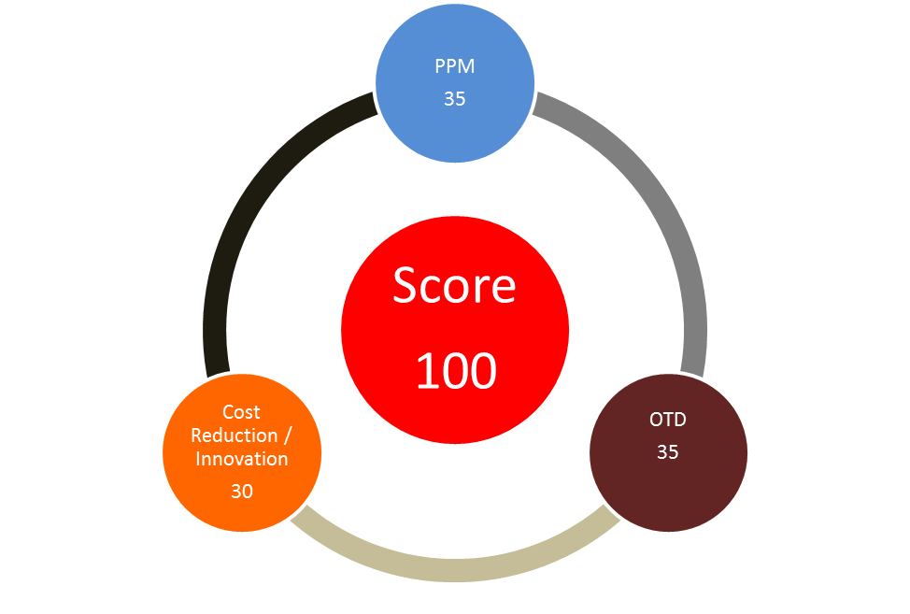

PPM Scoring
30 Points

0 PPM 35

1 - 5 PPM 30

6 – 10 PPM 25

11 – 20 PPM 20

21 – 30 PPM 15

31 – 49 PPM 10

> 50 PPM 0

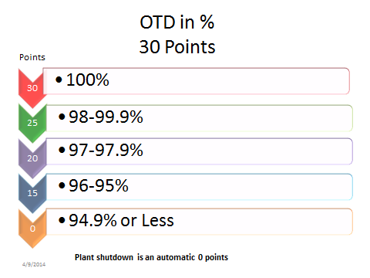

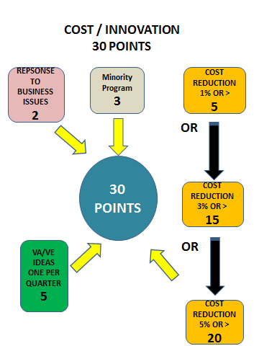

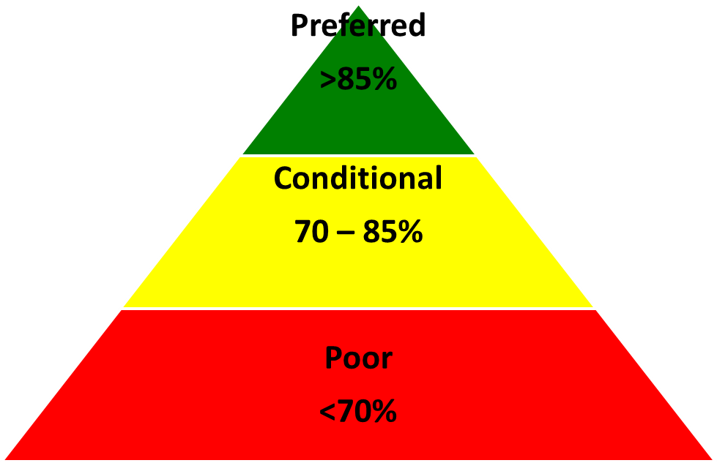
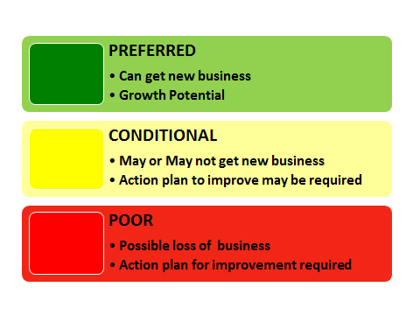

4. Problem Resolution
If a nonconformance issue is found at the plant, the plant may initiate a Supplier Corrective Action Request (SCAR). Janesville requires that a systematic problem-solving method be utilized. The Supplier is required to implement short-term and long-term corrective action plans and verify the effectiveness of the corrective action taken. Initial response/containment is required within 24 hours, and final response is required within 12 calendar days. The Janesville Plant Quality Assurance Manager must approve further extensions.
Suppliers should include opportunities to mistake-proof (Poka Yoke) the product or process and apply the corrective actions to all Janesville products in their facility (if possible). (Look across)

5. Supplier Response
Suppliers must respond to the SCAR by using the 8-D format.
Suppliers are to be fact- based and data driven in defining root causes.
Once a root cause has been identified Suppliers are to update all relevant documentation that is affected to standardize corrective actions into the quality system. For example, Process FMEA, control plan, and work instructions. .
These are some examples of processes to define root causes.
5 whys (Technical, Escape and Systemic Failure) (Required)
Is / Is Not (Optional)
Pareto Charts (Optional)
DOE (Optional)
Cause and Effect Diagrams (Required)
Updated PFMEA (Required)
Updated Control Plans (Required)
Updated Work instructions (Required)
Updated data sheet (Required)
Visual evidence (Required)

6. Supplier Quality Improvement Plan QIP
A supplier whose performance falls below 70% for two consecutive months will automatically be put on a Supplier Quality Improvement Plan.
This will be implemented by either the Supplier Quality Development Manager or the Director of Quality Assurance. The activity will be reviewed initially 2 x per month. If little or no progress is made, the meetings will be held weekly with the supplier. If the supplier does not improve their score within a quarter, the supplier will be put on bid suspension and actions may be taken to start re-sourcing the business.

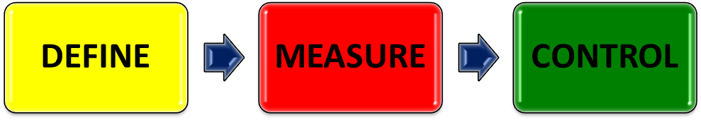

Example of 8-D flow Chart: 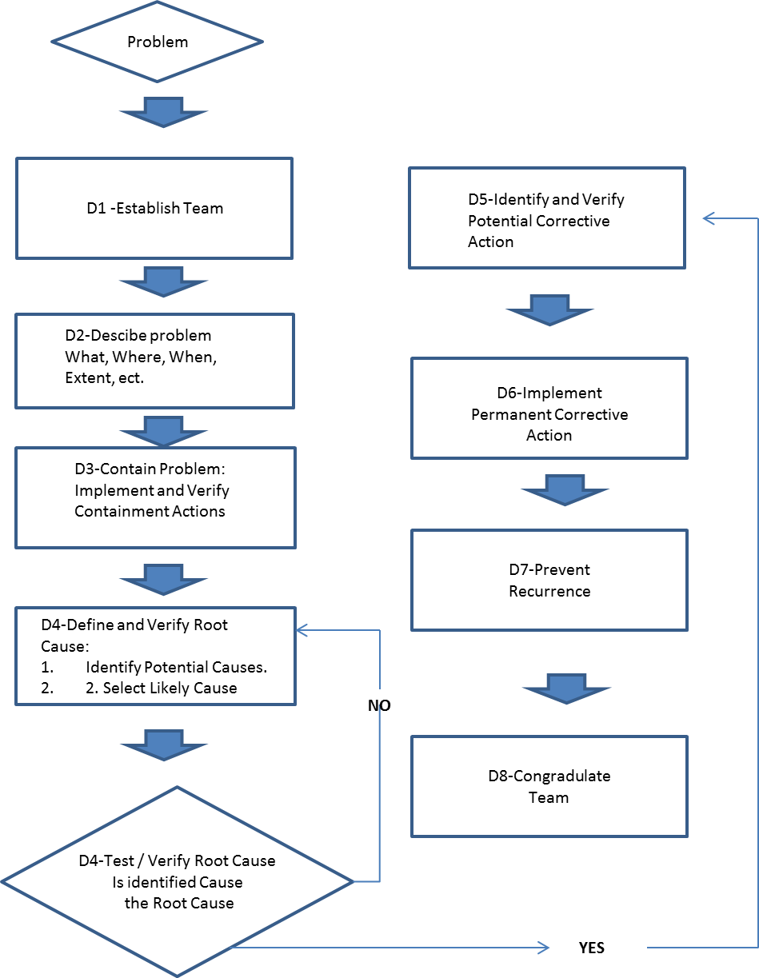

WHO IS EFFECTED BY THE PROBLEM? |  | Date Open: |  | 8D No.:
Company: |  | Initial Response: |  | Customer Complaint No.:
Address: |  | Target Close Date:
Location: |  | Revision Date(s):
Part No./Code |  | 8D Initiator:
Product Name: |  | 8D Initiator's Spvr:
 |  | Actual Close Date:
D1 TEAM MEMBER NAMES/TITLES: |  | D2 PROBLEM STATEMENT/DESCRIPTION (quantify) (one defect per 8D)
Champion:
Team Leader:
Team Members:
D3 CHOOSE AND VERIFY INTERIM CONTAINMENT ACTION(S) (ICA): |  |  |  | % Effective: | Target Date: | Actual Date:
HOW DID YOU VERIFY THE EFFECTIVENESS OF THE ICA?
D4 DEFINE AND VERIFY ROOT CAUSE(S): |  |  |  |  | % Contribution:
HOW DID YOU VERIFY THE ROOT CAUSE(S)?
D5 CHOOSE AND VERIFY PERMANENT CORRECTIVE ACTION(S) (PCA): |  |  |  |  | % Effective:
HOW DID YOU VERIFY THE EFFECTIVENESS OF THE PCA?:
D6 IMPLEMENT AND VALIDATE PERMANENT CORRECTIVE ACTION(S) (PCA): |  |  |  |  | Target Date: | Actual Date:
HOW WILL YOU VALIDATE THE PCA?
D7 SYSTEM PREVENTION ACTIONS TO PREVENT RECURRENCE: Mistake Proofing: How are you going to ensure it can't happen again? |  |  |  |  |  | Actual Date:
HAS CORRECTIVE ACTION/IMPLEMENTATION BEEN REVIEWED AGAINST DOCUMENTS?:
Check boxes that apply: | PFMEA
D8 TEAM AND INDIVIDUAL RECOGNITION: Recognize the collective efforts of the team.

Advanced Product Quality Planning (APQP)
JA performs APQP on its products and asks that program critical suppliers that are identified by the APQP Team participate with JA in this endeavor. The supplier and JA must understand and agree on all applicable quality standards and requirements. Agreement must be reached on all critical quality characteristics, control items, check fixtures, packaging requirements, and all other quality related matters.
Program Critical Suppliers identified by the APQP Team are responsible for creating Control Plans, Process Flow Charts, and Process Failure Mode Effects Analysis (PFMEA), etc., in order to substantiate conformance to all applicable product requirements. These suppliers are to follow the program elements in the APQP Timing Plan. Suppliers are not authorized until they receive PPAP approval, unless a written deviation has been granted by JA. APQP elements will be the following:
- Submit Team feasibility Commitment Form
- Source selection by JA
- Initiate APQP Activity
- Develop Product Quality Timing Plan
- Complete Preliminary Process Flow Diagram
- Complete Preliminary Listing of Special Product and Process Characteristics
- Design FMEA
- Design Review
- Review Specifications Engineering, Material, Drawing
- Review Subcontractor APQP Status
- Facility and Layout
- Complete Machinery, Equipment, Tooling Design and Build
- Prototype Builds
- Gage Reviews. Gage R&R Team Feasibility Commitment Form - Design
- Review Quality Systems, Procedures, Work Instructions
- Final Production Process Flow Chart
- Complete Process FMEA
- Complete Pre-Launch Control Plan
- Complete Packaging Specifications
- Complete PPAP Production Run, Capability Studies, Control Plans
- Complete Early Production Containment Plan
- Submit PPAP
- Complete Run @ Rate
- Submit IMDS
- Complete Conflict Minerals Report
- Lesson Learned Review

Document Revision History

Revision Control Log Date Comments Date
Revised
Revised

Prepared by Date  John Rogers 11/24/2014 | Reviewed/approved by Date  John Rogers 11/24/2014 | Reviewed/approved by Date  Management Representative:  Sandra Dorfman 11/25/2014

